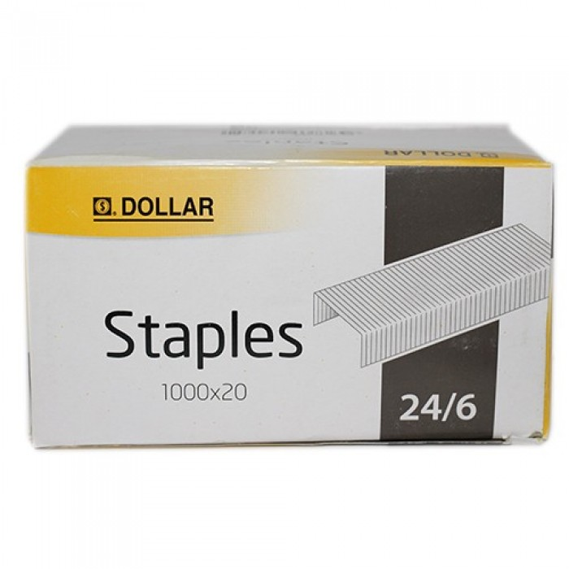

**Dollar Stappler Pin**

|  |  |
| --- | --- |
| BRAND | Dollar |
| ITEM DIMENSION | 2 x 4 x 12.13inches |
| MODEL NAME | Stappler Pin |
| COLOR | Silver |
| PRICE | **RS 30** |